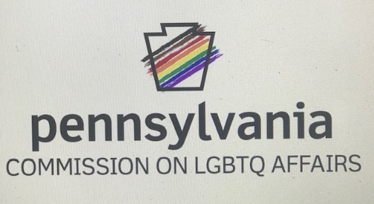

The Pennsylvania Commission on LGBTQ Affairs and the Keystone Business Alliance, Central PA's LGBT Chamber of Commerce, ardently believe in and advocate for the rights of every LGBTQ Pennsylvanian to be in public and participate fully in daily life with access to services and accommodations. LGBTQ Pennsylvanians deserve the dignity to access public places without the fear of being refused service because of their identities, being judged by aspects of their presentations or expressions, and being targets of harassment from staff or customers.
Our organizations challenge every business across this great Commonwealth to commit to serving all clients equitably and with respect. We believe these practices to not only be vital for economic and business growth in Pennsylvania but also able to occur without compromising personal, social, or religious freedoms.
We would also ask businesses and organizations to intentionally consider these ideas when identifying sub-contracts, vendors, and event spaces. By ensuring that our partners share in these ideologies and practices, we strengthen our united commitment to equality and comprehensive non-discrimination in the Commonwealth of Pennsylvania. Let us do everything we can to ensure that Pennsylvania remains the best state to work, live, and thrive for all members of our rich and diverse communities.

Todd Snovel Harry Young
He/Him/His He/Him/His
Executive Director Executive Director
Pennsylvania Commission on LGBTQ Affairs Keystone Business Alliance

